1. **[1] Did you setup Cloudera development environment on your machine?**You just need to write yes or no.

**yes**

1. **[2] What is the meaning of $HOME in your VM environment?**

**Home directory**

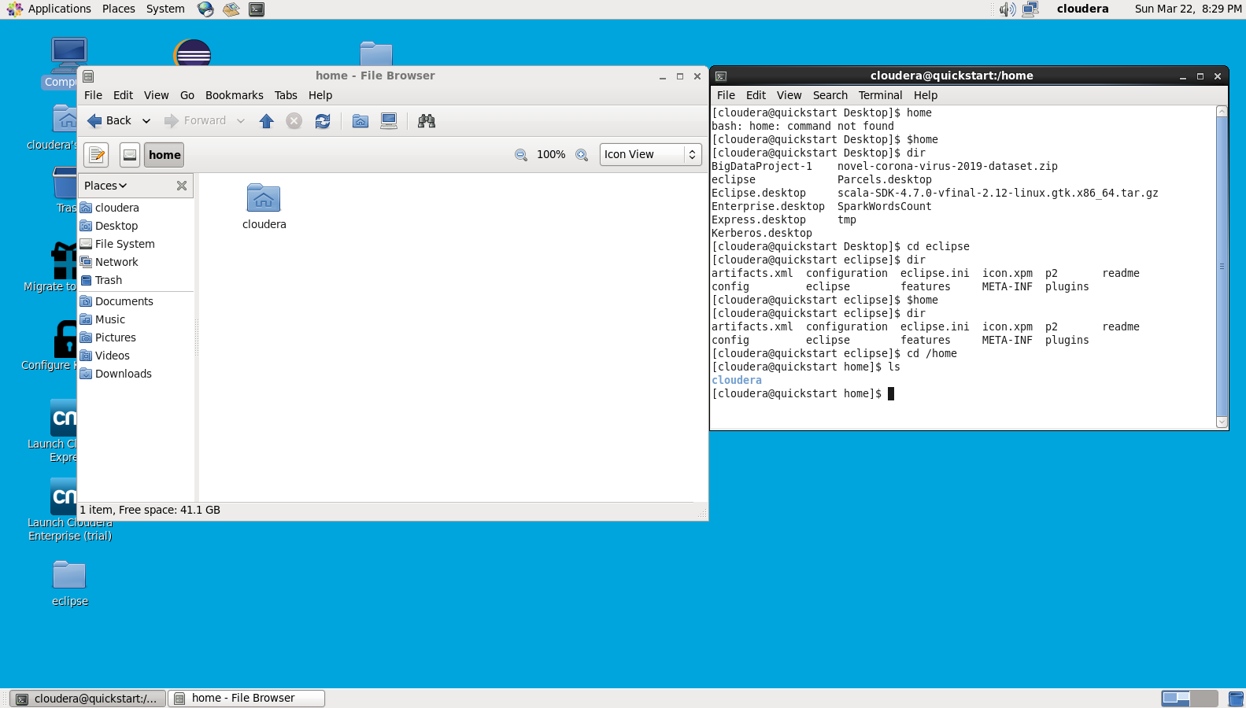

1. **[2] What is the meaning of *SUDO* in Unix/Linux environment?**

**Sudo allow user to use root privileges on commands, I prefer to use su.**

1. **[5] Write and briefly explain any 5 Unix/Linux commands.**  
   Paste screenshots of the results of executing these 5 commands in the “terminal” .

**ls & Dir 🡺 show all files and directories in current directory**

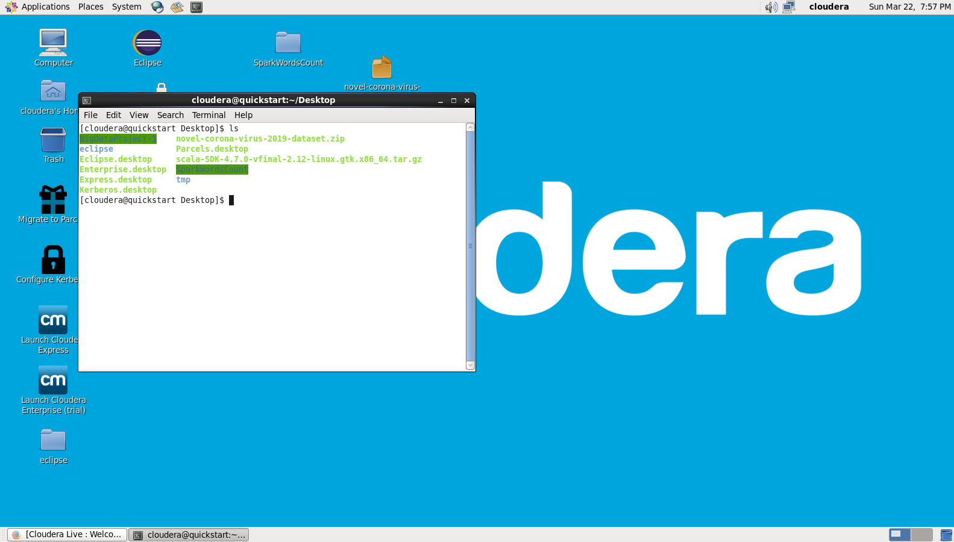

**cd🡺 open directory**

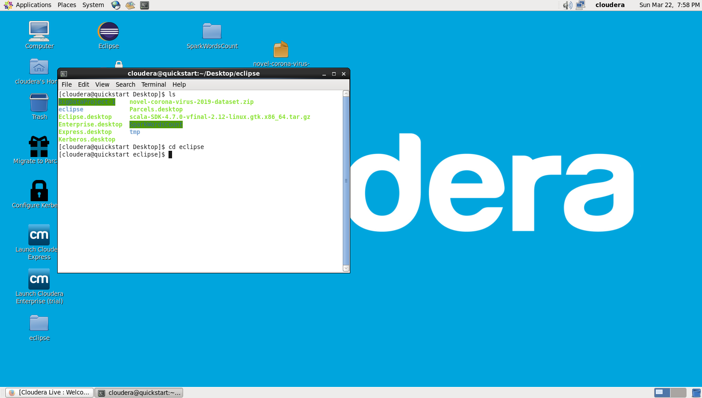

**mv 🡺 move file**

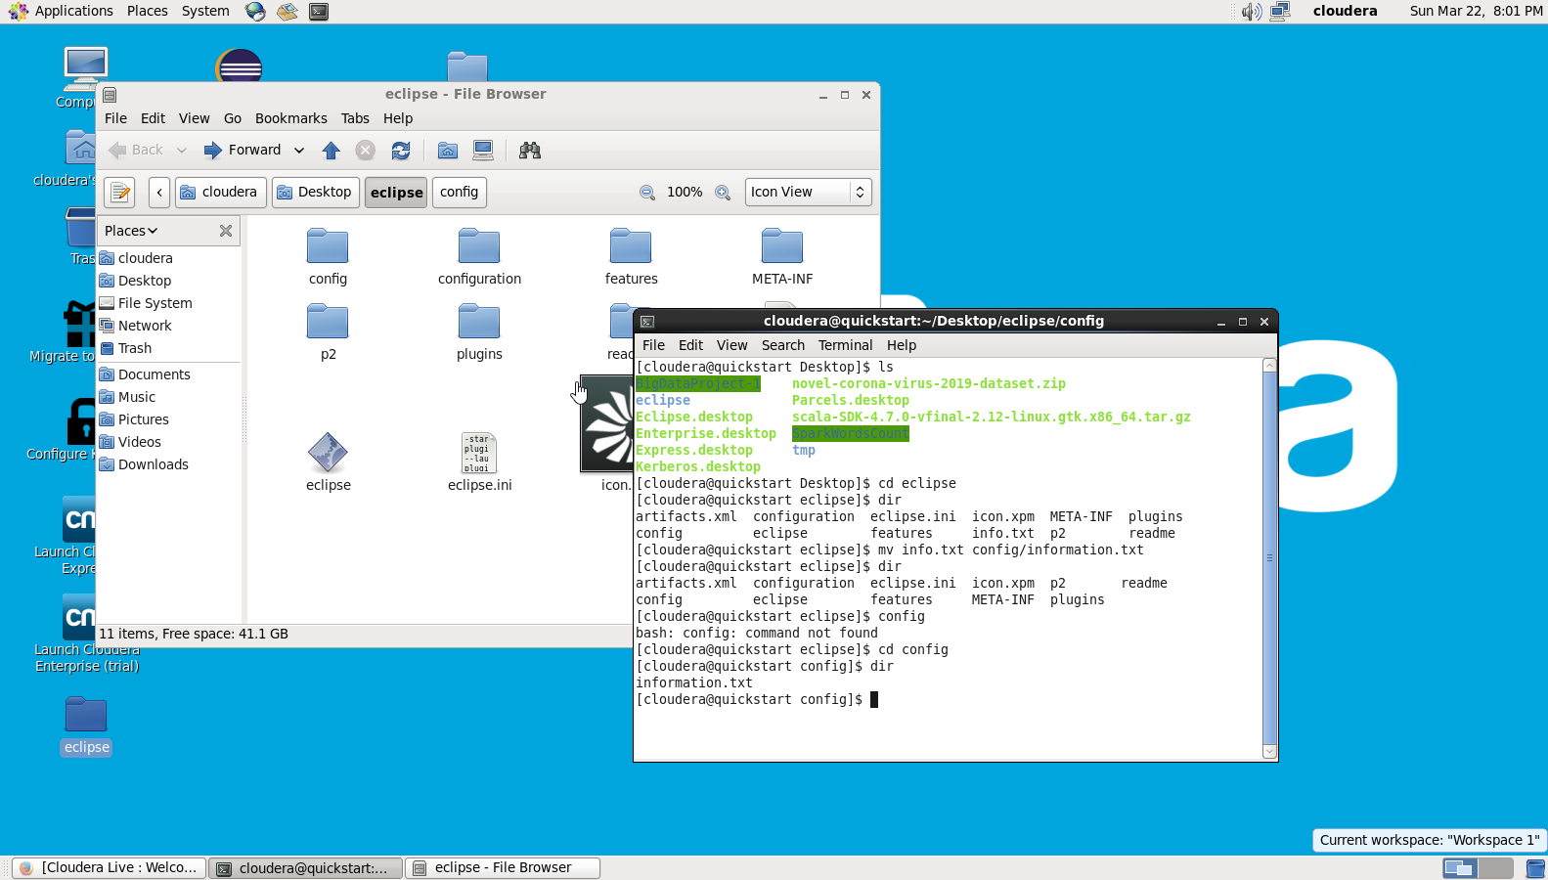

**rm🡺 remove files or directories**

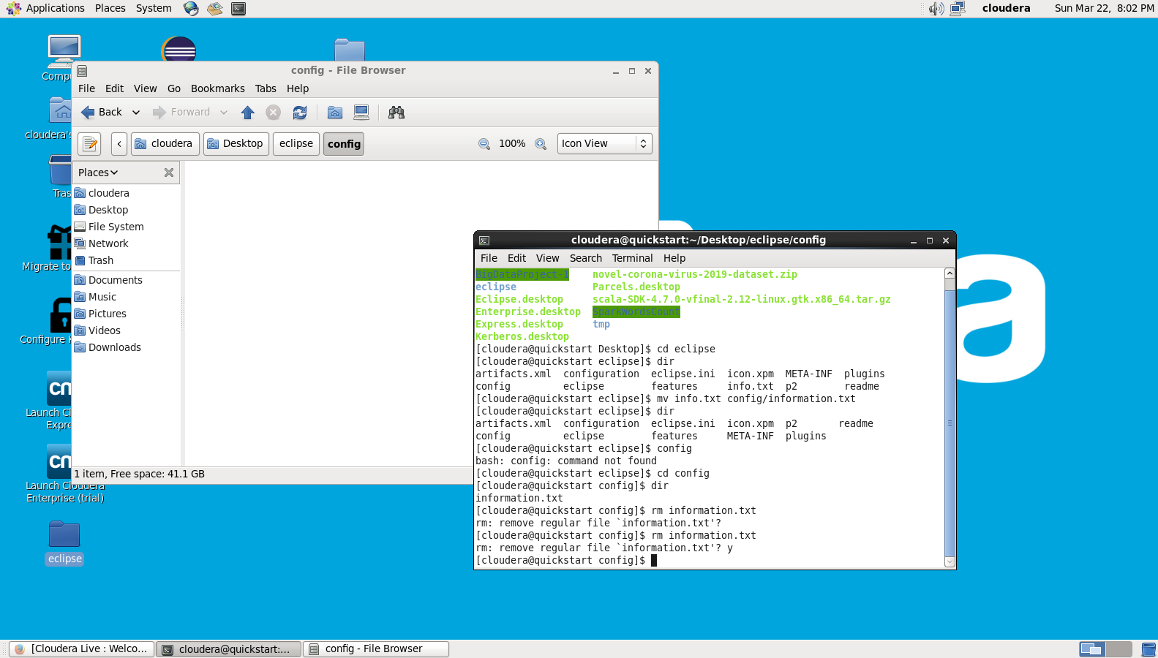

**mkdir 🡺 create new directory**

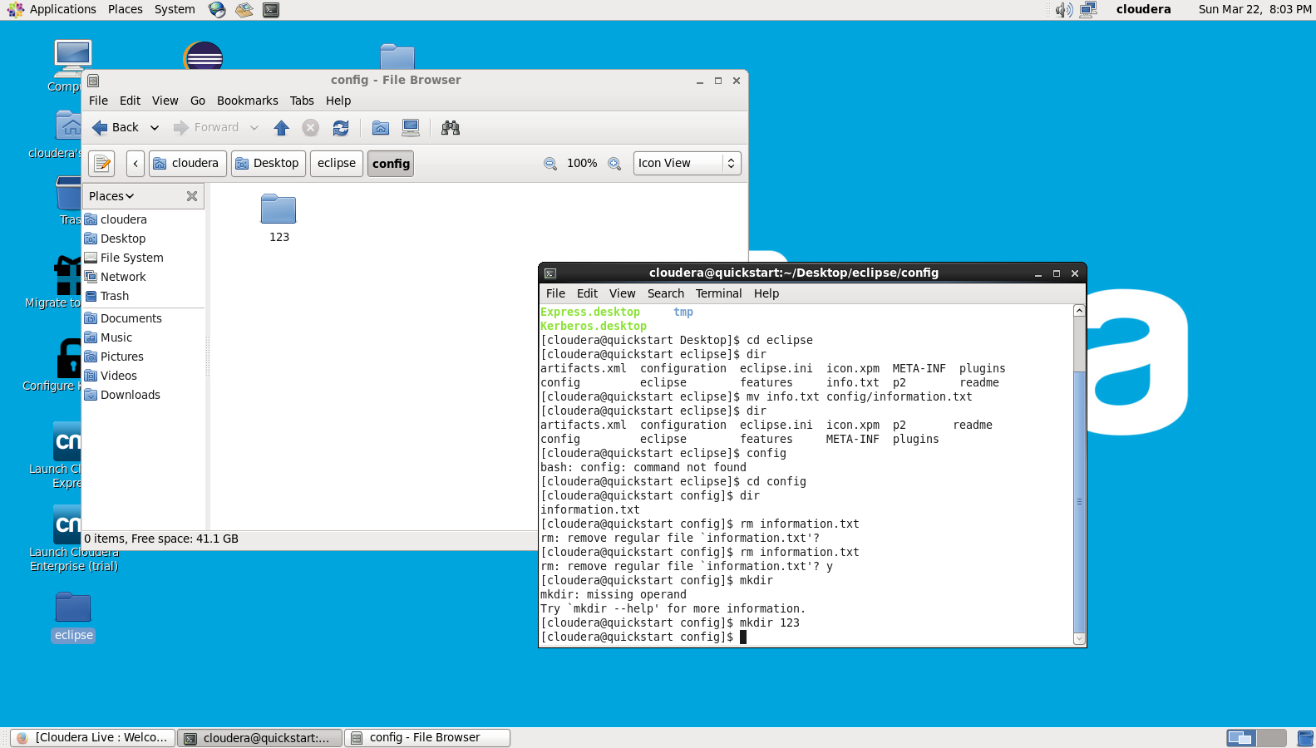

The purpose of questions 2, 3 and 4 is to motivate you to study some basics of Unix/Linux as that’s the main OS we’ll be working with in this course!